**Procedure:**

**Unit 4:**

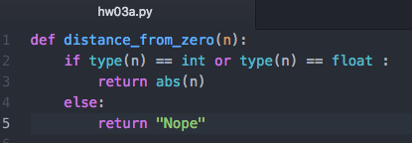

**Unit 5:**

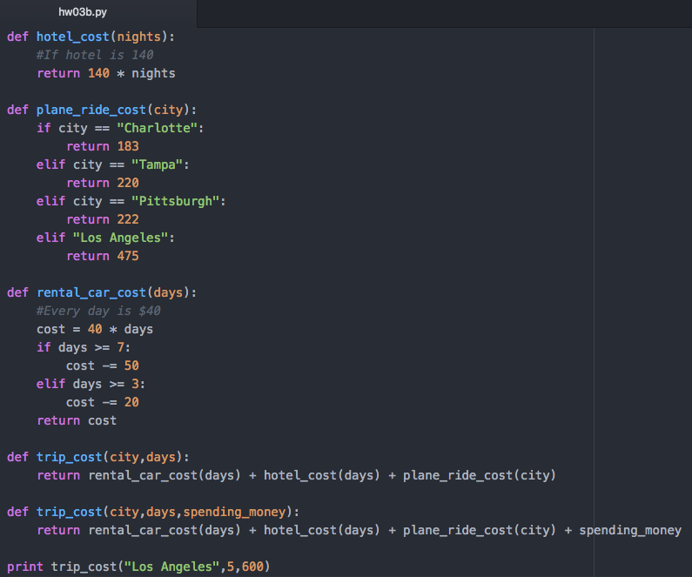

**Unit 7:**

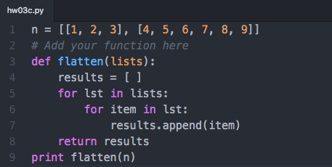

**Questions:**

**Unit 4:**

1. [ ] is the empty list values, the values insides are items used in a list

2. spam [2] = ‘hello’

3. ‘d’

4. ‘d’

5. [‘a’, ‘b’]

6. 1

7. [3.14, ‘cat’, 11, ‘cat’, True, 99]

8. [3.14, 11, ‘cat’, True ]

9. concatenation +, replication –

10. append () adds an item to the end of the list, insert() an item anywhere in the list with indication

11. the del statement & remove()

12. list values and string values both:

-have indexes and slices

-be concatenated and/or replicated

-be used in for loops

-in and not in operators

13. lists are mutable and uses [ ], tuples are immutable and uses ( )

14. (42,)

15. tuple 🡪 list, [( )]

list 🡪 tuple, (( ))

16. references to list values

17. copy.copy () will do a shallow copy of a list, copy.deepcopy () will do a deep copy of a list

**Unit 5:**

1. { }

2. {‘foo’:’42’}

3. items stored in a dictionary are unordered and itelsn in a list are ordered

4. KeyError error

5. no difference

spam = {‘cat’} checks if there is a ‘cat’ key in the dictionary

spam.keys(‘cat’) checks if there is a ‘cat’ key in the dictionary

6. spam = {‘cat’} checks if there is a ‘cat’ key in the dictionary

spam.values (‘cat’) checks if there is a value ‘cat’ for one of the keys in spam

7. spam.setdefault(‘color’, ‘black’)

8. pprint.pprint()

**Unit 6**

1. escape characters lets you use characters that would otherwise be impossible to put in a string

2. \n is new line (line break), \t is tab

3. \\

4. Howl’s isn’t escaped because you indicated the beginning and the end of a string with double quotation makrs

5. with multiline strings (three single or double quotes)

6. ‘e’

‘Hello’

‘Hello’

‘lo world!’

7. ‘HELLO’

True

‘hello’

8. [‘Remember’, ‘remember’, ‘the’, ‘fifth’, ‘of’, ‘November.’]

‘There-can-only-be-one.’

9. rjust(), ljust(), center()

10. lstrip() and rstrip()